Visit www.scal-sk8.org for the very latest:

Contest Results
Contest Schedules

Upcoming Contests:
Apr 24 2011 - Freestyle at Northridge
May 8 2011 - Dance and Figures at Fountain Valley
Jun 19 2011 - Freestyle at Orange
Jun 26-Jul 3 2011 - Regionals at Fresno Convention Center
Jul 24-Aug 7 2011 - Nationals in Fort Wayne, Indiana

Hosted by
Holiday Skate Center of Orange
175 N. Wayfield
Orange, CA 92867
(714) 997-5283
Scal-sk8.org
California State Games

February 19-20, 2011
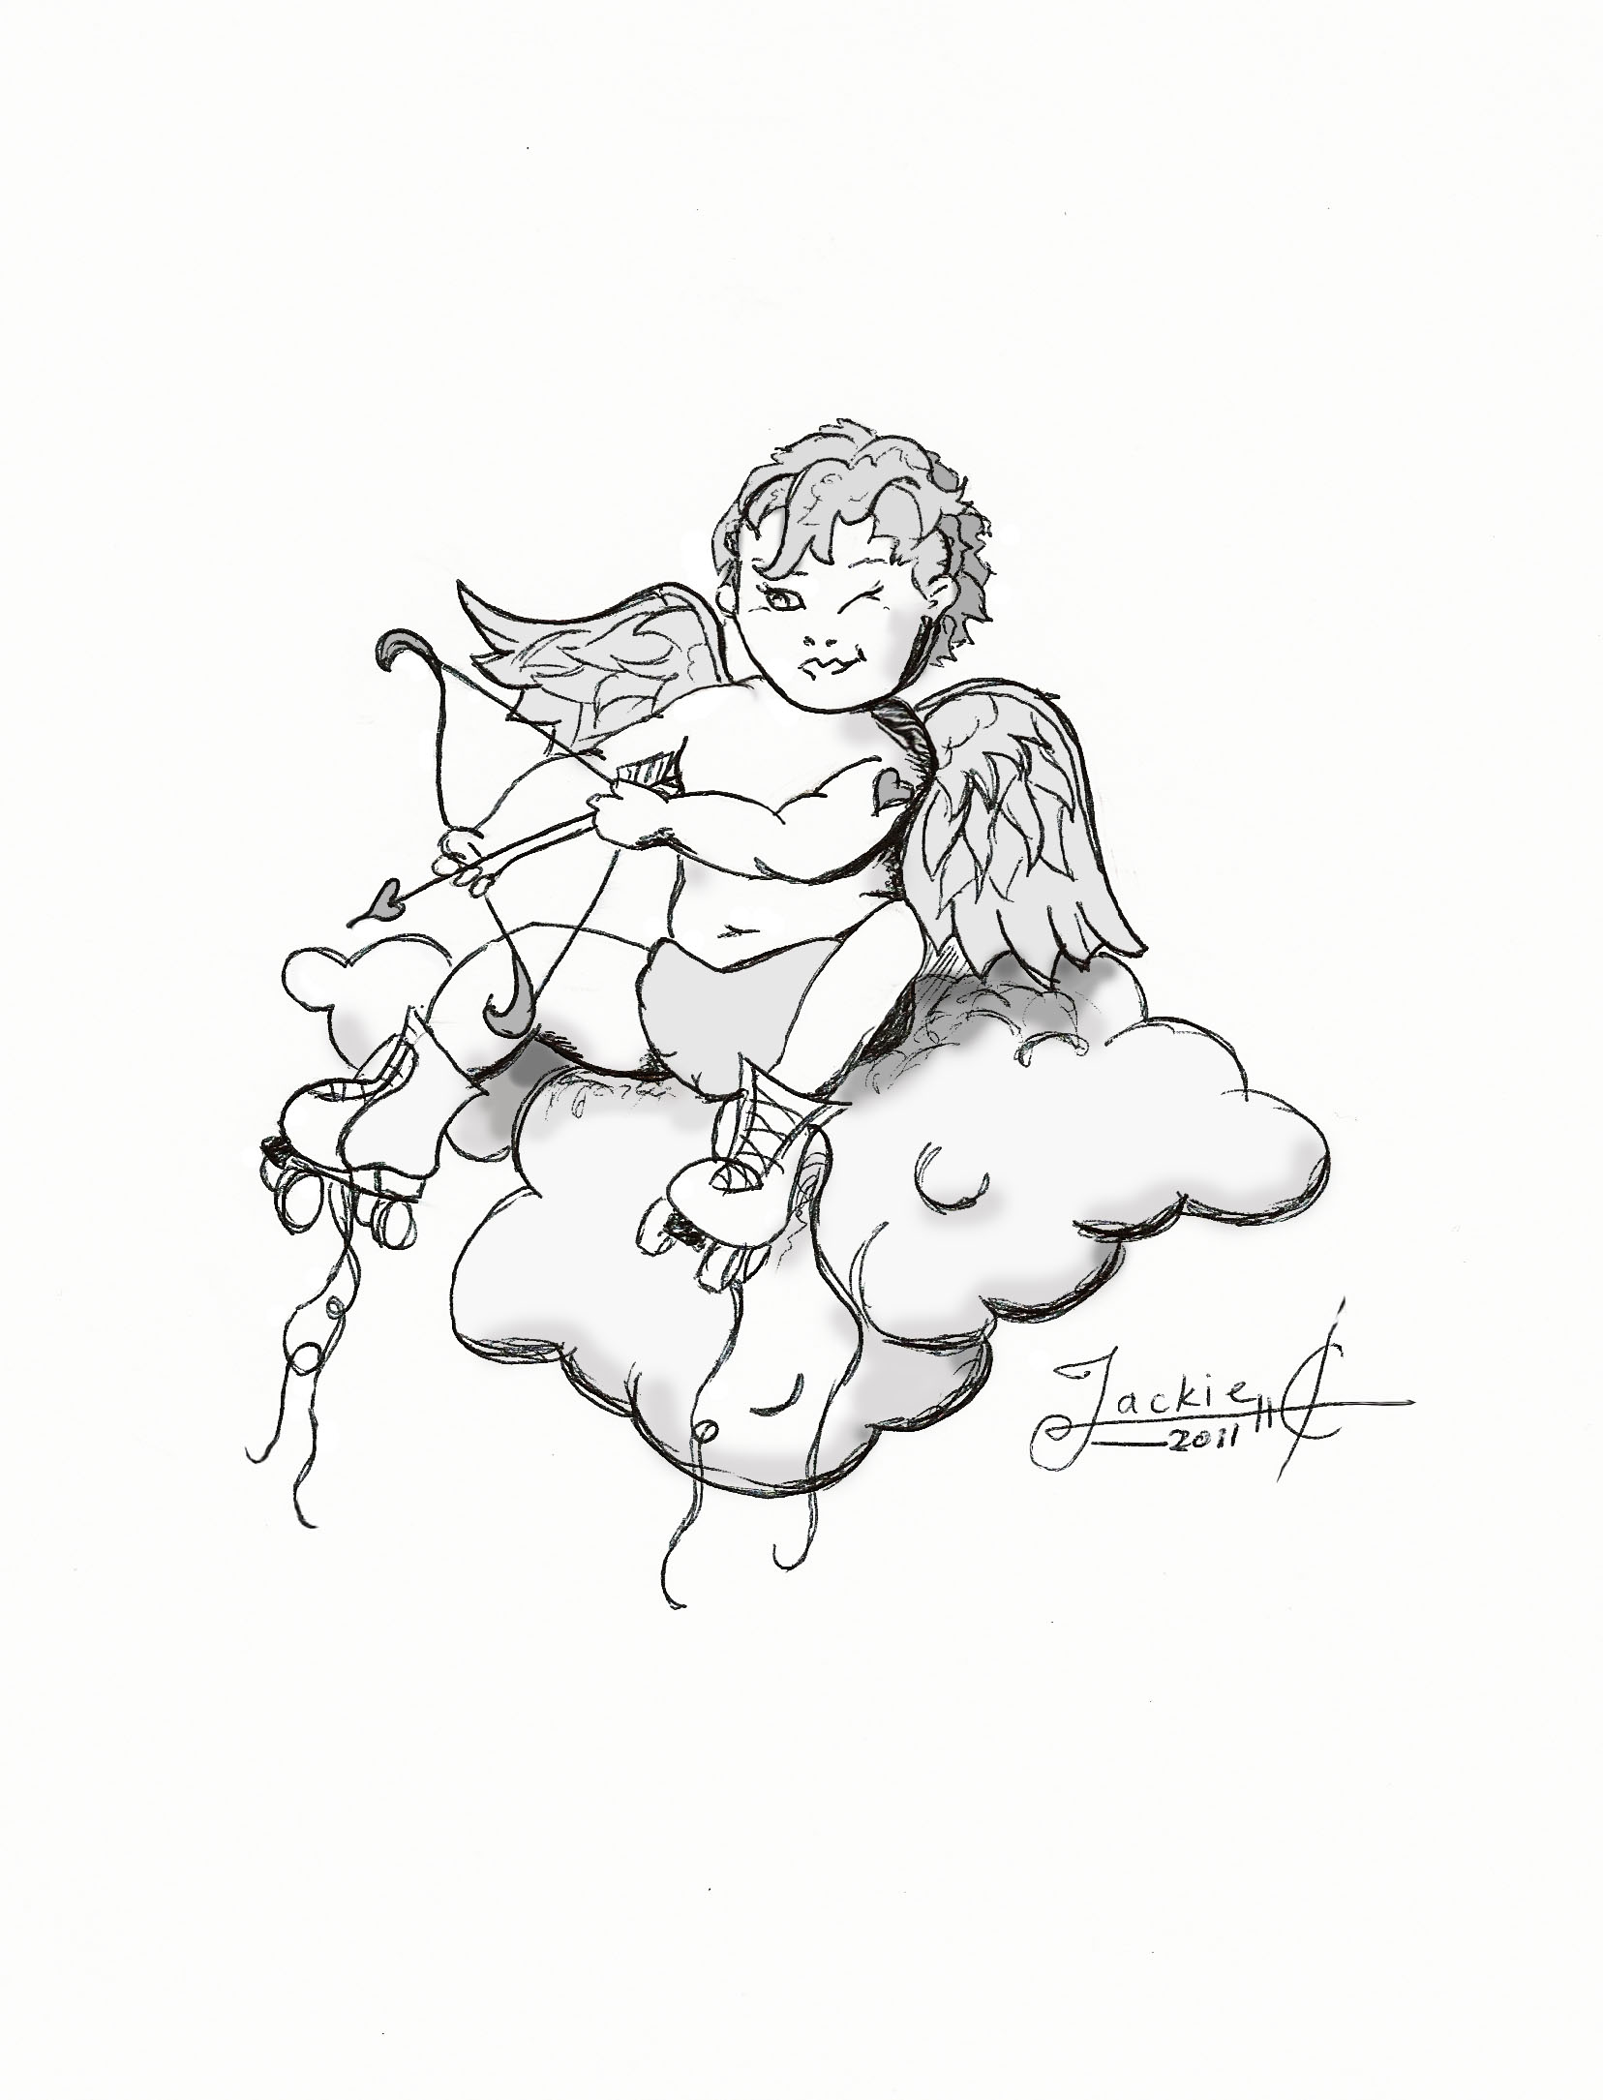
$2.00

