Visit www.scal-sk8.org for the very latest:

Contest Results
Contest Schedules

Upcoming Contests:
Feb 20 2011 - State Games at Orange
Apr 24 2011 - Freestyle at Northridge
May 8 2011 - Dance and Figures at Fountain Valley
Jun 19 2011 - Freestyle at Orange
Jun 26-Jul 3 2011 - Regionals at Fresno Convention Center
Jul 24-Aug 7 2011 - Nationals in Fort Wayne, Indiana

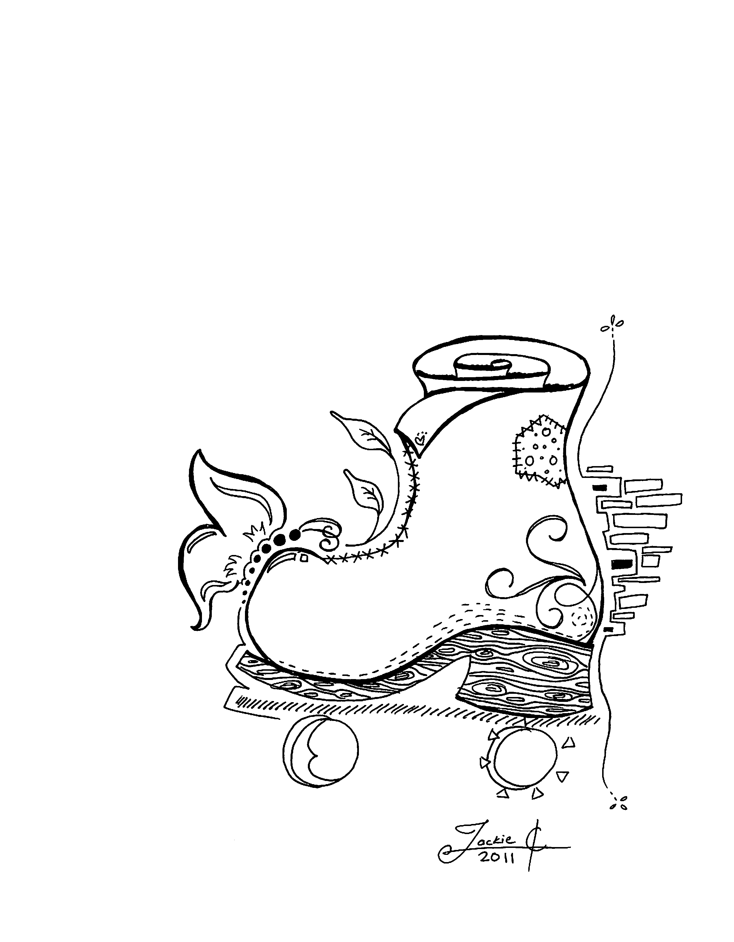
January 23, 2011
Hosted by
Moonlight Rollerway
5110 San Fernando Road
Glendale, CA 91204
(818) 241-3630 Ext “0”
$2.00
Southern California Area League
Scal-sk8.org
Dance and Figures Contest

